**About the Project and Its Data**

**Introduction**

The COVID-19 pandemic significantly impacted global health, economies, and daily life. Understanding and analyzing COVID-19 data is essential for identifying patterns in infection rates, recoveries, fatalities, and vaccination progress. This project, developed using Python, performs exploratory data analysis (EDA) on COVID-19 datasets, offering visual insights into how the virus spread across regions and over time.

**Problem Statement**

Governments, researchers, and the public faced difficulties in interpreting the vast and rapidly growing COVID-19 data. The absence of accessible, visual tools made it hard to monitor key metrics like daily confirmed cases, deaths, and vaccination rates. This project addresses the need for a structured, interactive, and visual approach to analyze COVID-19 data and derive actionable insights.

**Theory**

The project is based on the following core concepts:

* **Data Collection**: Reading up-to-date COVID-19 datasets from sources such as WHO, Johns Hopkins, or Kaggle.
* **Data Preprocessing**: Cleaning null values, converting data types, and filtering unnecessary columns.
* **Exploratory Data Analysis (EDA)**: Summarizing main characteristics using visual and statistical methods.
* **Visualization**: Using graphs to observe trends and compare country-level and global-level progress.

**Advantages**

* **Real-Time Insights**: Users can explore and monitor COVID-19 trends interactively.
* **Comparative Analysis**: Enables comparison of cases and deaths between countries or states.
* **Data Quality Awareness**: Helps identify missing or inconsistent data across time periods.
* **Informed Decisions**: Supports policy makers and individuals in making data-backed decisions.
* **Hands-on Learning**: Reinforces concepts in data analysis, visualization, and Python

coding.

**Flow Chart**

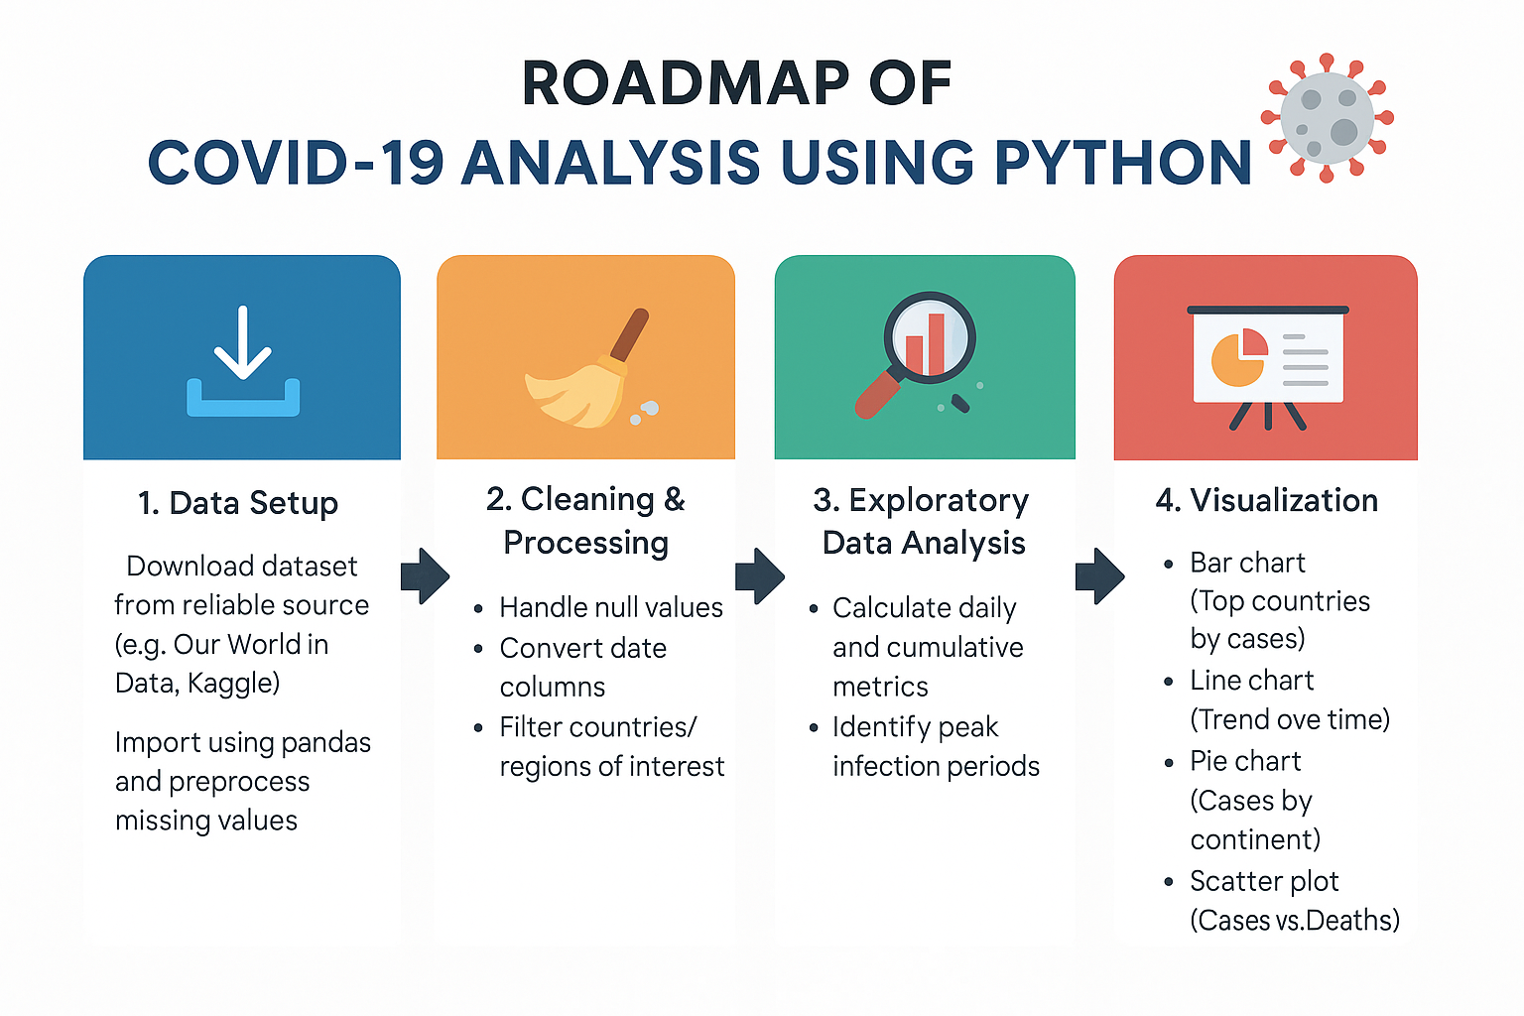

**Key Terms**

* **Confirmed Cases**: Total reported COVID-19 infections.
* **Deaths**: Number of individuals who died due to COVID-19.
* **Recovered**: Patients who recovered from the virus.
* **Active Cases**: Current cases excluding recovered and deaths.
* **Vaccination**: Data related to doses administered, partially and fully vaccinated individuals.
* **Rolling Average**: Smoothing metric to show trends more clearly.

**Project Roadmap**

1. **Data Setup**
   * Download dataset from reliable source (e.g., Our World in Data, Kaggle)
   * Import using pandas and preprocess missing values
2. **Cleaning & Processing**
   * Handle null values
   * Convert date columns
   * Filter countries/regions of interest
3. **Exploratory Data Analysis**
   * Calculate daily and cumulative metrics
   * Identify peak infection periods
4. **Visualization**
   * Bar chart
   * Line chart
   * Pie chart
   * Scatter plot

**Classification Report**

If machine learning is applied for predicting outbreak trends or classifying risk levels, a classification report can be generated using:

* **Precision**: Accuracy of predicted labels
* **Recall**: How well actual positives are identified
* **F1-Score**: Harmonic mean of precision and recall

**Life Cycle of the Project**

1. Requirement Analysis
2. Dataset Selection
3. Data Cleaning
4. Analysis & Visualization
5. Reporting & Conclusions

**Key Observations**

* Countries with early lockdowns saw delayed or lower spikes in cases.
* Vaccination rollout data correlates with a decline in active cases.
* Daily new cases often spike after social holidays or policy changes.
* Data from some countries contains significant gaps or inconsistencies.
* Death rates vary by region, often due to healthcare availability and reporting standards.

**Conclusion**

This COVID-19 Data Analysis project uses Python to transform raw pandemic data into meaningful insights through visualization and statistics. It helps track the progression of the virus, compare country responses, and monitor recovery efforts. The project provides a valuable foundation for data-driven decision making and highlights how data science can play a crucial role in addressing global challenges.

**Data Visualisation using Charts**

**Introduction**

Data visualization transforms raw data into graphical formats, making it easier to interpret. In this diabetes prediction context, visualization reveals trends, outliers, and patterns that inform model development.

**Visualizations**

**Line Plot**

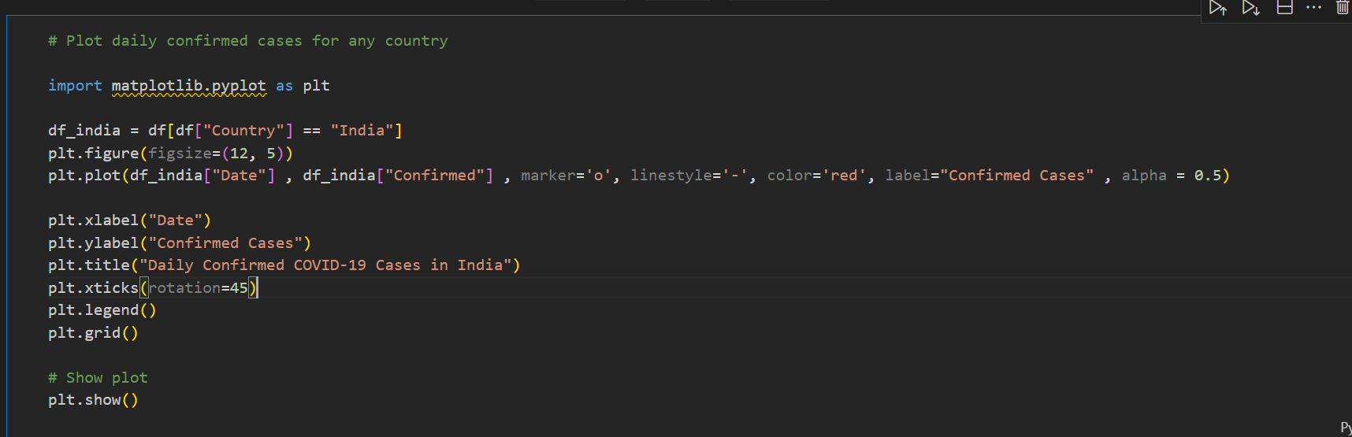

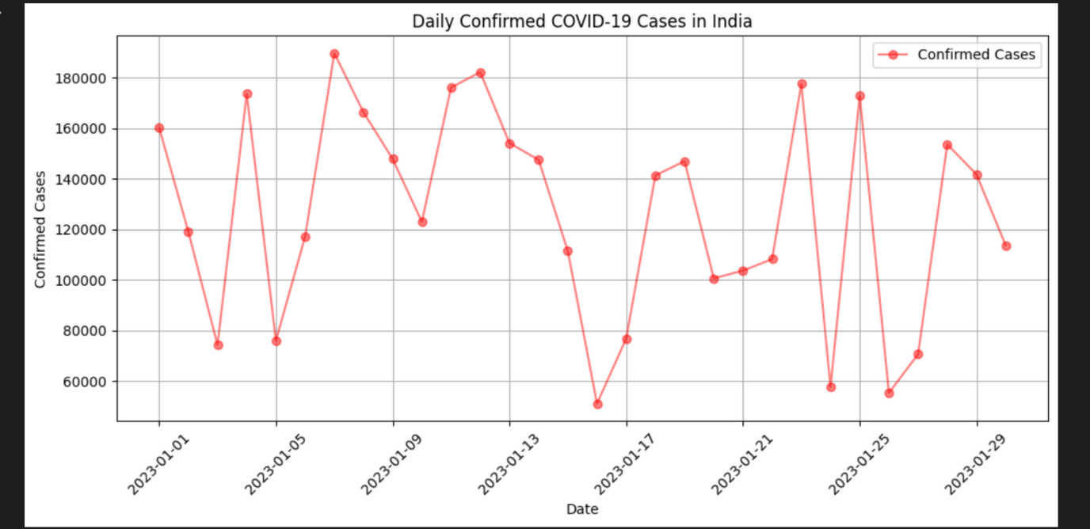

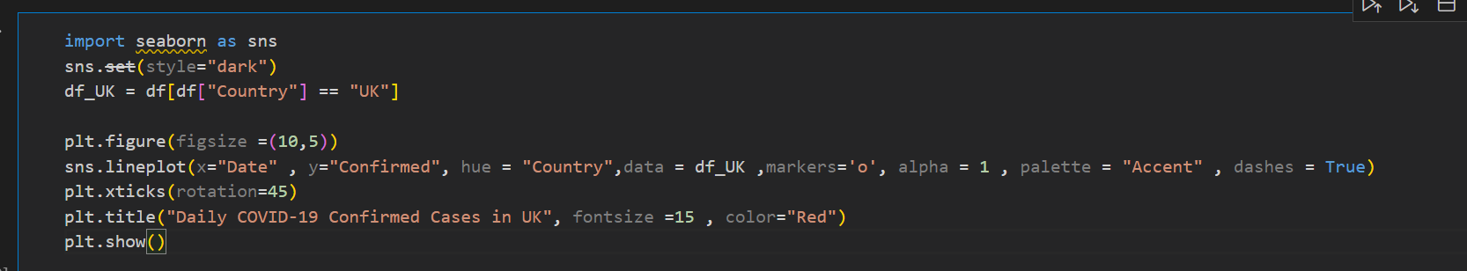

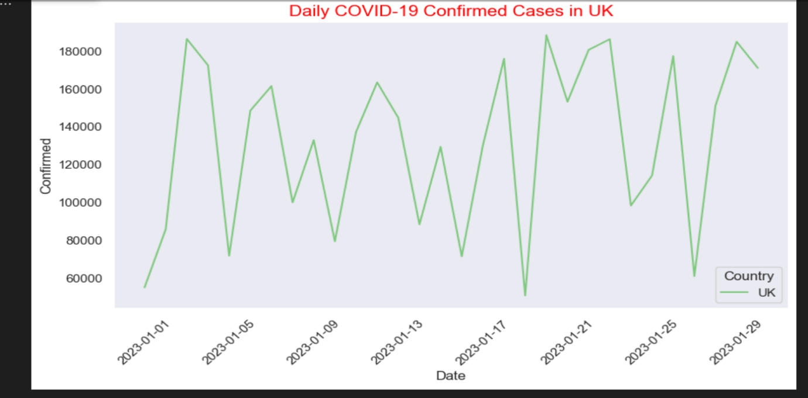

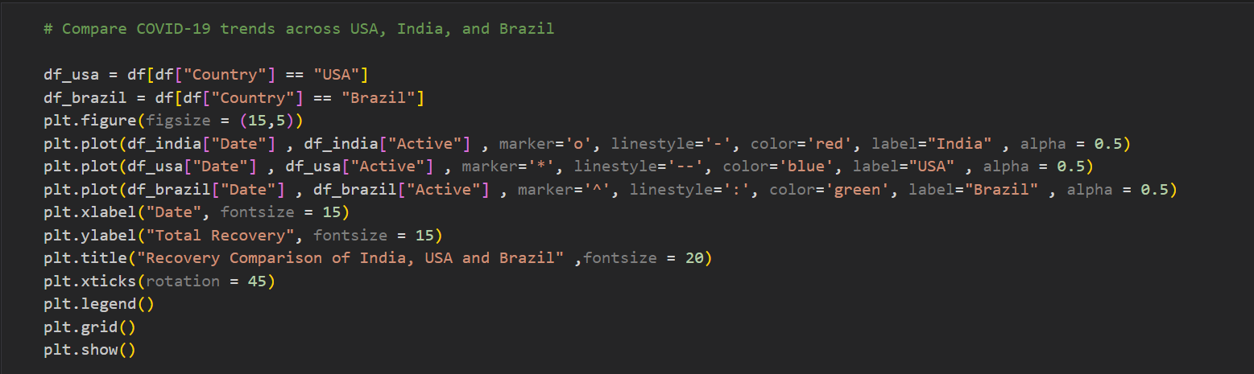

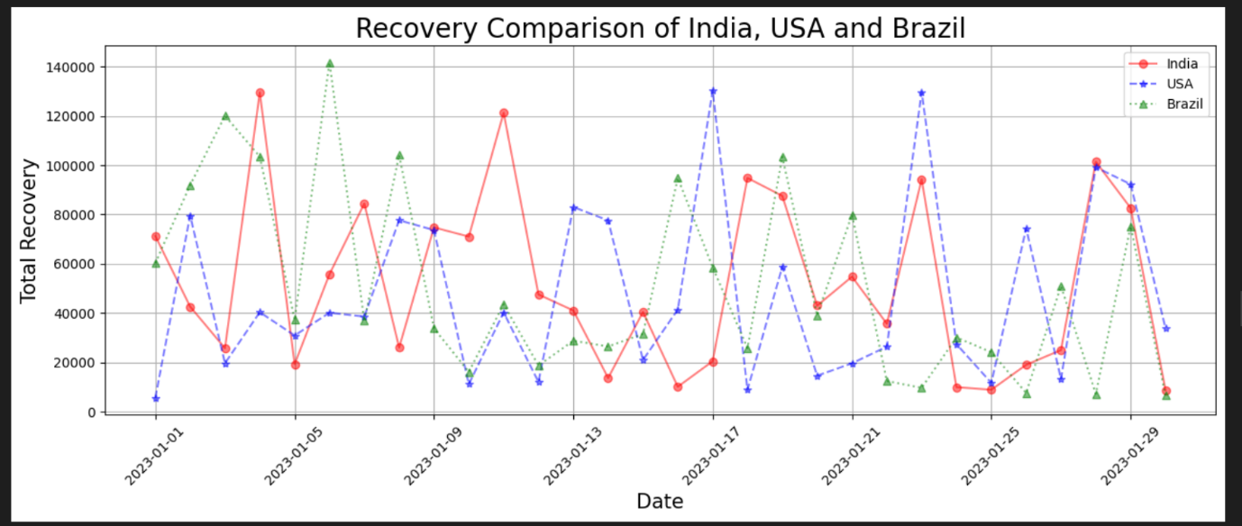

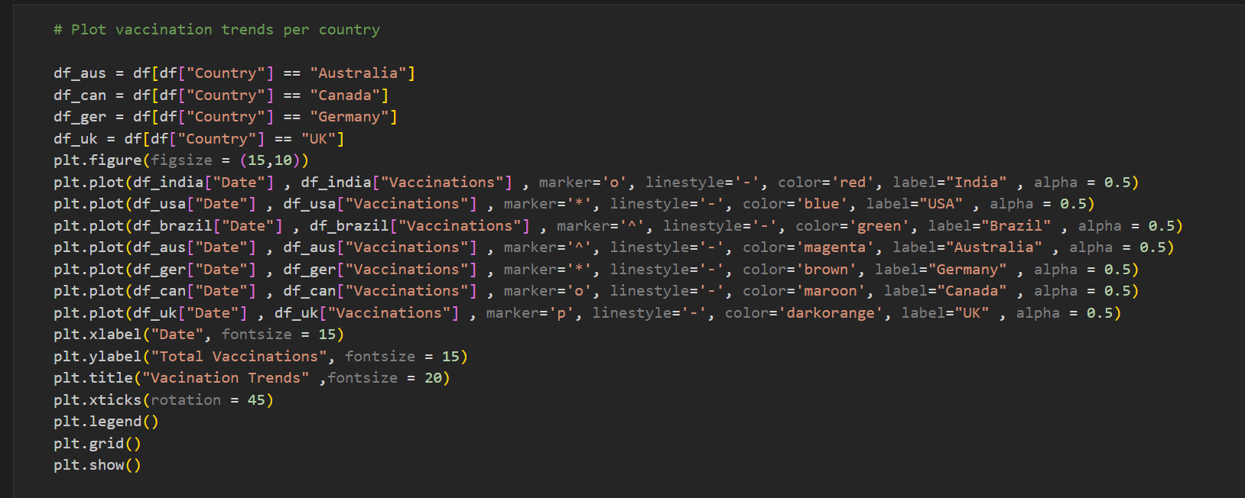

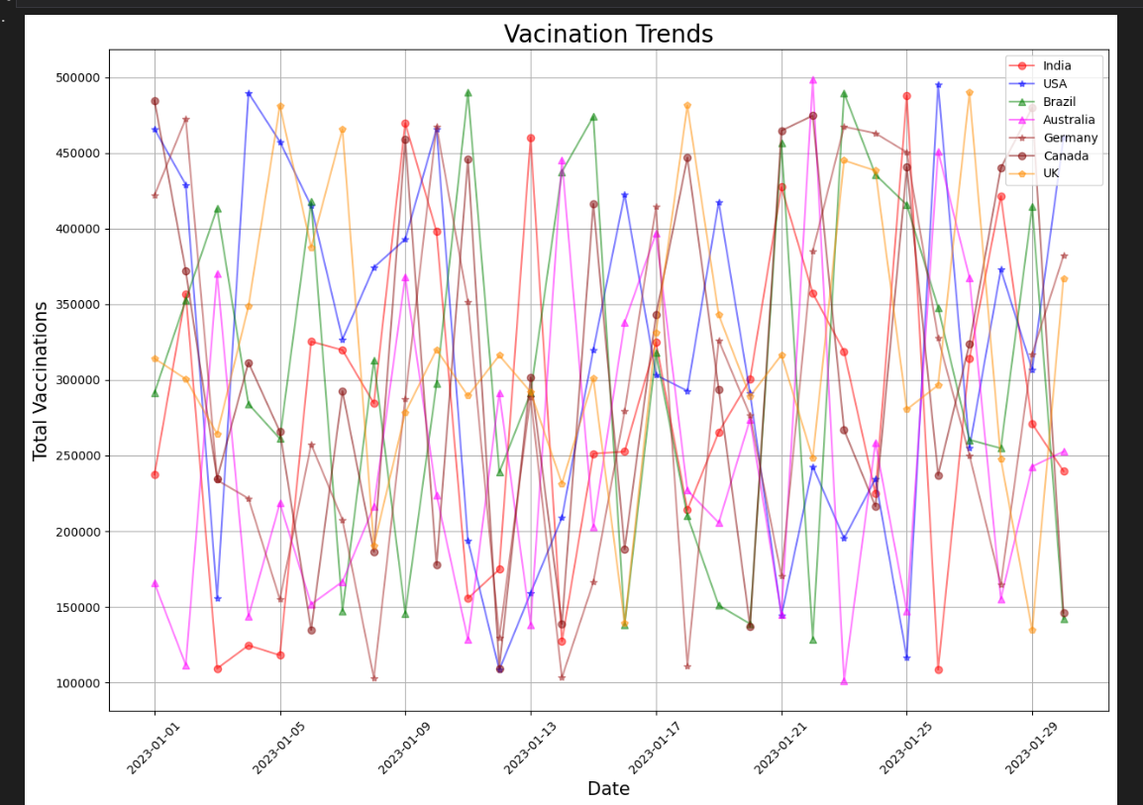

**Scatter Plot**

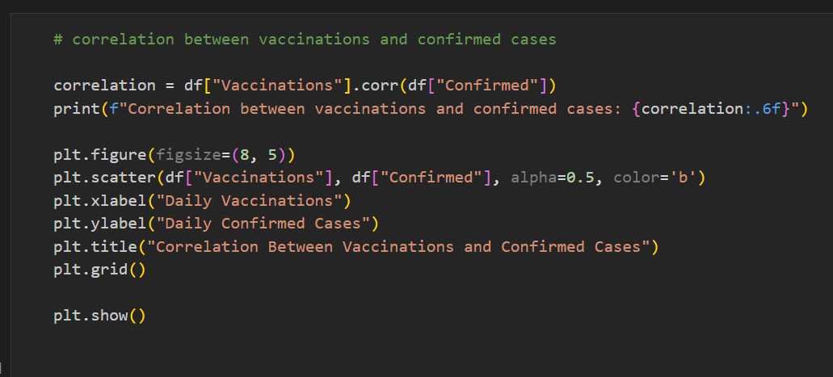

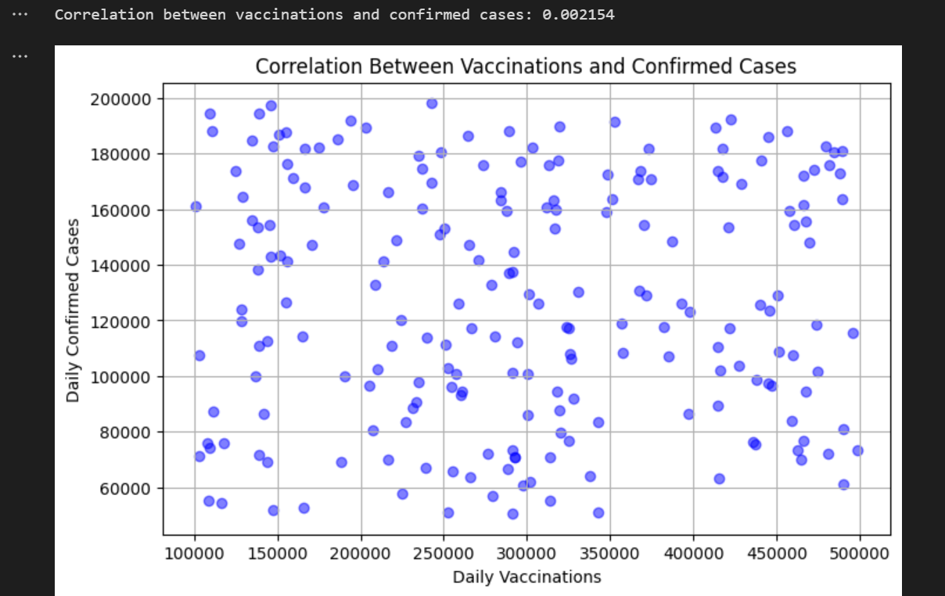

**Conclusion**

These visualizations revealed:

* Diabetic patients tend to have higher average glucose and BMI.
* There's a class imbalance: more non-diabetic than diabetic patients.
* Age and glucose are positively correlated in certain groups.
* Visualization supports feature selection and model tuning for diabetes prediction.